Java multithreading
Multithreading in the java is a feature that allow multiple tasks/thread to run simultaneously/concurrently within same program
-instead of executing one task at a time java enables parallel execution using lightweight threads
-this makes application more, efficient ,faster and responsive in real world scenario like server, games and chat system
Feature of the multithreading:
- A thread is smallest unit of execution in java
- Share the same memory space but run independently
- To create a thread java provides Thread class and Runnable interface to create threads
- It ensures the better CPU utilization by executing tasks simultaneously
- Synchronization is needed to prevent data inconsistency when threads share resources
1.Introduction of the multithreading
2.thread class and runnable interface
3.thread lifecycle
4.thread methods and priorities
5.Synchronization
6.inter-thread communication
7.Deadlocka and thread safety
8.locks and synchronizers
A thread is lightweighted, independent unit of execution inside a program(process)
-a process can have multiple thread
-each thread runs independently but shares same memory
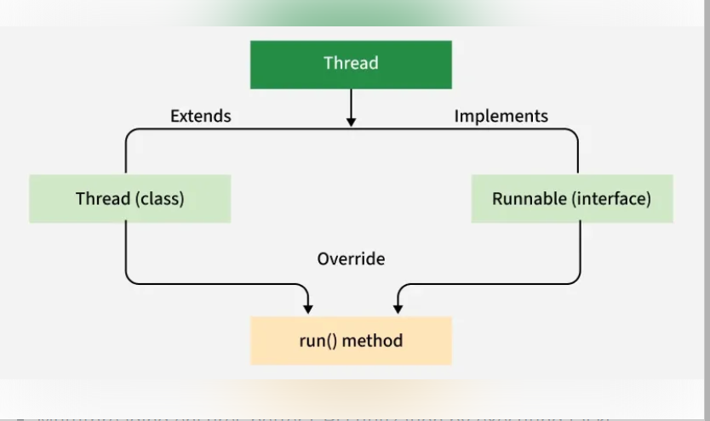
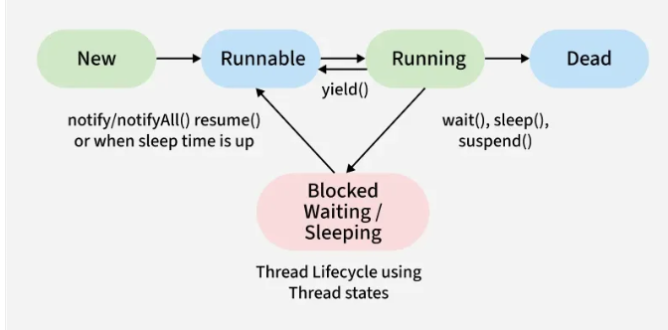
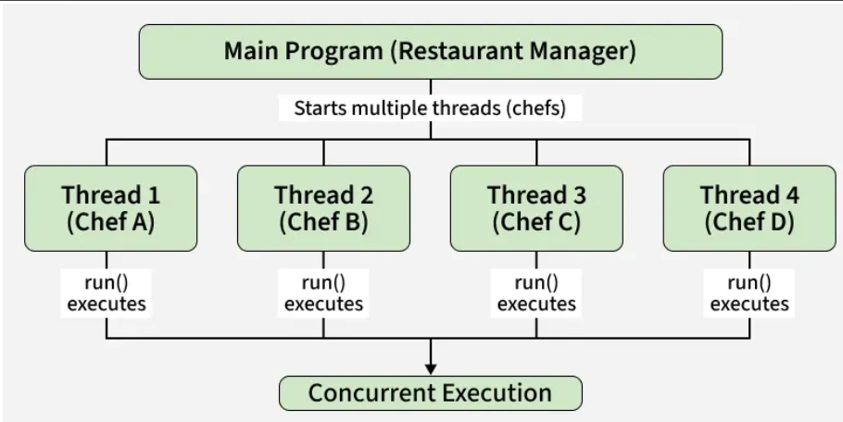
Different way of creating the thread
1.extending Thread class:
-we create a new class that extends Thread class from java.lang.Thread; package
-then override it’s run() method to define task
-make object of class and call start() method which automatically call the run() and begin thread execution

Example:/*
1.extending Thread class:
------------------------------------------------------------------------------------------------------
-we create a new class that extends Thread class from java.lang.Thread; package
-then override it’s run() method to define task
-make object of class and call start() method which automatically call the run() and begin thread execution
---------------------------------------------------------------------------------------------------------
*/
class first extends Thread{
public void run(){
System.out.println("thread1 is running");
}
}
class second extends Thread{
public void run(){
System.out.println("tread2 is running");
}
}
class Cook extends Thread{
private String task;
Cook(String task){
this.task=task;
}
public void run(){
System.out.println(task+" is being prepared by "+Thread.currentThread().getName());
}
}
class Cook1 extends Thread{
private String task;
Cook1(String task){
this.task=task;
}
public void run(){
System.out.println(task+" is being prepared by "+Thread.currentThread().getName());
}
}
public class multithread1 {
public static void main(String[] args) {
System.out.println("create object of class that extends thread class and call thread using start");
first f=new first();
second s=new second();
f.start();
s.start();
System.out.println("----------------------------------");
System.out.println("pass object of class to thread class and call start method");
Cook1 c1=new Cook1("pasts");
Cook1 c2=new Cook1("salad");
Thread t1=new Thread(c1);
Thread t2=new Thread(c2);
t1.start();
t2.start();
System.out.println("----------------------------------");
System.out.println("use object of the class extends Thread of reference type thread class and call start method execute the task ");
Thread t3=new Cook("desert");
Thread t4=new Cook("Rice");
t3.start();
t4.start();
}
}

2.implementing Runnable interface
-we create a class which implements java.lang.Runnable interface
-override the run() method class that implement runnable interface to define task
-create a Thread object .pass your runnable object to thread constructor
-call the start method on thread object
Example:
class base extends Thread{
private String task;
base(String task){
this.task=task;
}
public void run(){
System.out.println(task+" is being prepared by "+Thread.currentThread().getName());
}
}
class base1 implements Runnable { // implements Runnable
private String task;
base1(String task) {
this.task = task;
}
@Override
public void run() { // override run()
System.out.println(task + " is being prepared by " + Thread.currentThread().getName());
}
}

}}
public class RunnableInterface {
public static void main(String[] args) {
System.out.println("crete constructor object and pass object to thread class using thread object call start method");
base b1=new base("pizza");//b1 is thread and also runnable
Thread t1=new Thread(b1); //thread constructor accept Runnable.thread implements Runnable
t1.start(); //start t1
System.out.println("direct start -----------------------");
base b2=new base("Sandwich");
b2.start();
//to use the object with thread the class must implement Runnable because thread's constructor expects a runnable object
System.out.println("pass direct constructor object to thread class and call the start method");
Thread t2=new Thread(new base1("burger"));//pass inline object
t2.start();
}
}
When to use which?
1)Use extends Thread : if your class does not extends any other class
2)Use implements Runnable: if your class already extends another class (preferred because java doesn’t support multiple inheritance)

Aspect | extends Thread | implements Runnable
Inheritance | Occupies the only available extends slot → cannot extend another class | Frees up extends slot (since it’s an interface) → more flexible
Separation of concerns | Mixes task (run()) with thread control (start(), join()) | Clean separation: Runnable = task, Thread = executor
Reusability | Task logic tied to one Thread instance → cannot reuse | Same Runnable can be reused across multiple Threads or in ExecutorService
Modern APIs | Doesn’t integrate well with ExecutorService, Callable, etc. | Works seamlessly with ExecutorService, Callable, Future, etc.
Testing | Harder to test task logic (need real thread) | Easy to test run() directly without threads
When to use | When you want to specialize/modify Thread class itself | When you just want to define a task (✅ preferred in most cases)

Criteria | extends Thread | implements Runnable
Multiple Inheritance | ❌ Not possible to extend any other class since Java allows only single inheritance | ✅ Possible, because class can extend another class while implementing Runnable
Design Principle | Couples task and thread → less flexible | Separates task (Runnable) from execution (Thread) → clean design
Reusability | Task code is bound to the Thread object → not reusable | Same Runnable can run in multiple threads or with executors
Modern Concurrency Support | Limited, mostly legacy | ✅ Works with ExecutorService, ThreadPool, Callable, Future
Testing | Harder to test; requires thread start | Easy to test run() directly without thread
Best Practice | Use only if you want to override/customize Thread class behavior | ✅ Preferred in real projects and interviews because of flexibility & clean design

Good question 👌 This is often asked in interviews.
- extends Thread → Tightly Coupled
  - The task (run logic) and the execution mechanism (Thread class) are bound together.
  - You cannot separate the work from the thread — if you want to reuse the task, you must create another thread object.

- implements Runnable → Loosely Coupled
  - The task (Runnable) and the executor (Thread / ExecutorService) are independent.
  - You can pass the same task to different threads, reuse it in a thread pool, or even run it synchronously (by calling run() directly).
🔎 In-Depth Reasons Why Runnable is Preferred
1. Separation of Concerns (OOP Principle)
- Thread = execution mechanism (worker).
- Runnable = task logic (job).
- By using Runnable, we decouple what to do from how to run it.
👉 This makes the design cleaner and follows Single Responsibility Principle (SRP).

2. Avoids Inheritance Limitation
- Java supports only single inheritance.
- If you extend Thread, your class cannot extend any other class (e.g., JFrame, Applet, HttpServlet).
- Using Runnable frees up the extends slot, so your class can still inherit from another base class.

3. Reusability of Task Logic
- A Runnable can be:
  - Executed by multiple Thread objects.
  - Submitted to an ExecutorService (thread pool).
  - Tested independently (without threads).
- With Thread, the task is tightly bound to one thread object → not reusable.

4. Flexibility with Modern Concurrency Frameworks
- Java 5+ introduced ExecutorService, Callable, Future, ForkJoinPool`, etc.
- These APIs work seamlessly with Runnable (and Callable).
- If you only use Thread, you cannot directly leverage these frameworks.

5. Better Testability & Maintainability
- A Runnable is just a normal object with run() → you can test its logic directly in unit tests (no need to spawn a thread).
- With Thread, you must start a new thread, which makes testing harder.

6. Memory Efficiency & Resource Sharing
- Creating too many Thread objects is costly (each thread consumes stack memory).
- Using Runnable, you can share the same task instance across multiple threads → less memory footprint.
- Example: Thousands of clients running the same Runnable task via thread pool.

7. Encourages Loose Coupling (Good Design)
- Runnable objects don’t care how they will be executed — they can run:
  - In a single thread
  - In multiple threads
  - In a scheduled executor
- This makes the system loosely coupled and easier to extend.

✅ Interview-Ready Summary
Runnable is preferred because it provides clean design (separation of task and execution), avoids inheritance limitation, promotes reusability, integrates with modern concurrency APIs, supports better testing, reduces memory overhead, and ensures loose coupling.
Thread should only be extended if you specifically want to customize thread behavior.
🔎 In Runnable, Each Task Shares the Same Resources
- When you implement Runnable, you can create one task instance and pass it to multiple Thread objects.
- Since all those threads are running the same Runnable object, they share the same instance variables (resources/state).
Example:
class CounterTask implements Runnable {
private int count = 0; // shared resource
@Override
public void run() {
for (int i = 0; i < 5; i++) {
count++;
System.out.println(Thread.currentThread().getName() + " -> count: " + count);
}
}
}

public class Test {
public static void main(String[] args) {
CounterTask task = new CounterTask(); // one shared task
Thread t1 = new Thread(task, "Thread-1");
Thread t2 = new Thread(task, "Thread-2");
t1.start();
t2.start();
}
}
Output (interleaved, shared):
Thread-1 -> count: 1
Thread-2 -> count: 2
Thread-1 -> count: 3
Thread-2 -> count: 4
👉 Both threads update the same count because they share the same Runnable instance.

🔎 In Thread (when extended), Resources Are Not Shared by Default
class CounterThread extends Thread {
private int count = 0; // not shared (each thread has its own copy)
@Override
public void run() {
for (int i = 0; i < 5; i++) {
count++;
System.out.println(getName() + " -> count: " + count);
}
}
}
public class Test2 {
public static void main(String[] args) {
CounterThread t1 = new CounterThread();
CounterThread t2 = new CounterThread();
t1.start();
t2.start();
}
}
Output (independent counters):
Thread-0 -> count: 1
Thread-1 -> count: 1
Thread-0 -> count: 2
Thread-1 -> count: 2
👉 Each thread has its own count because they are separate objects.

✅ Interview-Ready Point
- Runnable: If the same Runnable instance is shared → all threads share its resources (instance variables). Useful when threads need to work on the same data.
- Thread: Each Thread object has its own state → no automatic sharing of resources.

⚠️ Bonus (to impress interviewer):
If multiple threads share resources via Runnable, you must use synchronization (synchronized, Lock, Atomic variables) to prevent race conditions.
Thread lifecycle:
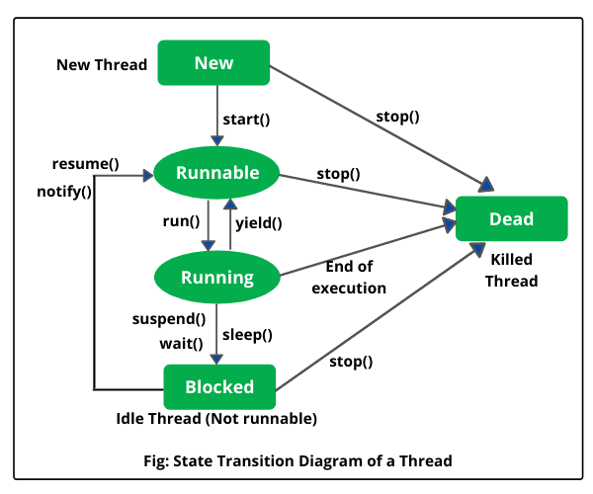

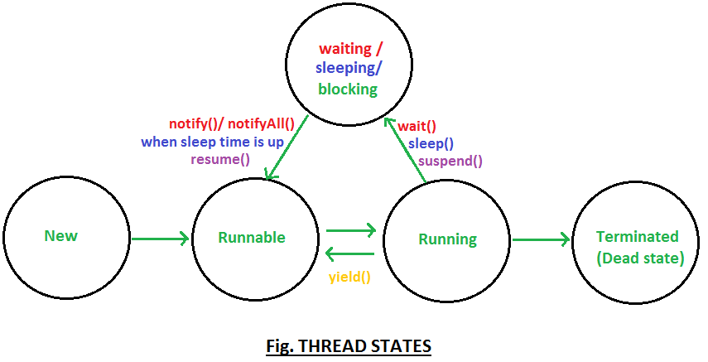

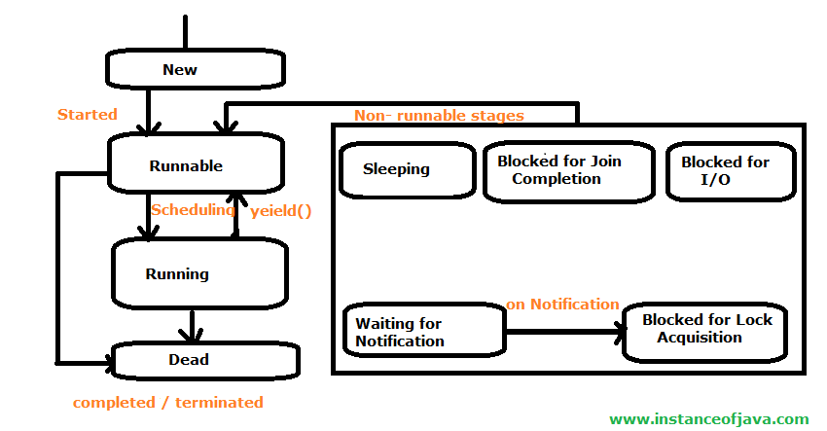
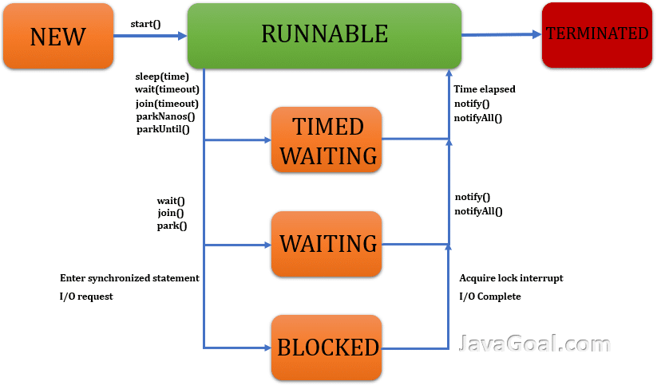
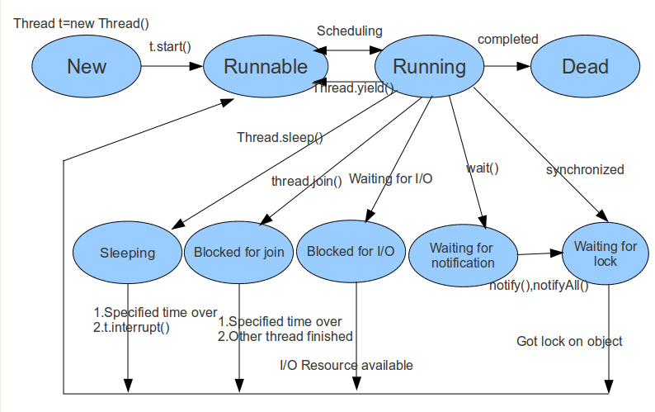
1)NEW State:
-Thread is created but not yet started. Exists after you create it with new Thread() but before calling .start()
-call .start() to move from NEW to RUNNABLE
2)RUNNABLE
-thread is ready to run or is running the cpu schedular decides when it actually executes
RUNNING → WAITING / TIMED_WAITING / BLOCKED
- Happens if the thread is paused, waiting for a lock, or sleeping.
WAITING / TIMED_WAITING / BLOCKED → RUNNABLE
- When the wait ends, lock is acquired, or timeout finishes.
A thread that is ready to run is moved to a runnable state. In this state, a thread might actually be running or it might be ready to run at any instant of time. It is the responsibility of the thread scheduler to give the thread, time to run. A multi-threaded program allocates a fixed amount of time to each individual thread. Each and every thread get a small amount of time to run. After running for a while, a thread pauses and gives up the CPU so that other threads can run.

3)RUNNABLE TO RUNNING
-CPU schedular picks the thread to execute
-Running state is not valid thread state in java
3)BLOCKED
-thread is waiting to acquire a lock to enter a synchronized block/method
4)WAITING:
-thread is waiting indefinitely for another thread to signal it(e.g via wait() or join() without timout)
5)TIMED_WAITING
-thread is waiting for a specific time(e.g sleep(ms), joins(ms)) or wait(ms)
-thread is finished its execution or stopped due to error
6)TERMINATED
-thread has finished execution/stop or stopped due to an error
- Because it exits normally. This happens when the code of the thread has been entirely executed by the program.
- Because there occurred some unusual erroneous event, like a segmentation fault or an unhandled exception.

State | Description | Example / Trigger
1. New | Thread is created but not started. | Thread t = new Thread();
2. Active | Thread has been started and is under CPU scheduling. | t.start();
➤ Runnable | Ready to run, waiting for CPU time. | Waiting in queue for CPU
➤ Running | Actively executing on CPU. | CPU assigns time slice
3. Waiting / Blocked | Thread is inactive, waiting for a condition or resource. | Waiting for lock or signal
➤ Waiting | Waiting indefinitely for another thread to complete. | wait() or waiting for resource release
➤ Blocked | Trying to access a locked resource. | Competing for synchronized block
4. Timed Waiting | Paused for a specific time, then resumes. | sleep(1000), join(timeout)
5. Terminated | Task completed or thread stopped. Cannot restart. | run() ends or stop() called

🔄 Transitions Between States
- New → Active: When start() is called.
- Active → Runnable → Running: Managed by the Thread Scheduler.
- Running → Runnable: After time slice ends.
- Running → Waiting/Blocked/Timed Waiting: Based on resource availability or method calls.
- Any → Terminated: When execution completes or thread is stopped.
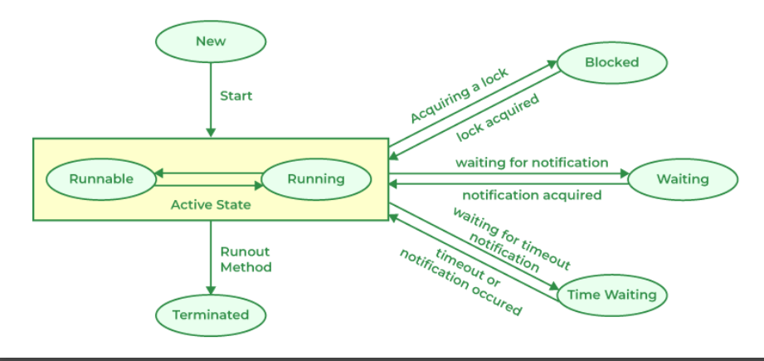

The common mistake is starting a thread using run() instead of start() method
Thread t1=new Thread(object of class);
T1.run(); //should be start()
Note: we use start() to launch a new thread which then calls the run() method in parallel .
if we call run() directly it works like a normal method call and no new thread is created

Java Thread class
-thread class is a part of the java.lang package , which is used to create and manage thread
-thread class provides the constructor and methods to perform operation on threads
public class Thread extends Object implements Runnable
-Thread is a subclass of object
-it implements the Runnable interface which require a run() method
Key constructors
-Thread()-create a new thread without a target
-Thread(Runnable target)-create a thread that execute the run() method of the given Runnable object
-Thread(String name)-create a thread with specific name
-Thread(Runnable target,String name)-combine both target and name

🧵 1. Thread()
Creates a thread without a target. You typically override the run() method in a subclass.
class MyThread extends Thread {
public void run() {
System.out.println("Thread with no target is running.");
}
}
public class Main {
public static void main(String[] args) {
Thread t = new MyThread(); // Using default constructor
t.start();
}
}
🧩 2. Thread(Runnable target)
Creates a thread that runs the run() method of a Runnable object.
class MyRunnable implements Runnable {
public void run() {
System.out.println("Thread with Runnable target is running.");
}
}

public class Main {
public static void main(String[] args) {
Runnable r = new MyRunnable();
Thread t = new Thread(r); // Runnable passed as target
t.start();
}
}
🏷️ 3. Thread(String name)
Creates a thread with a specific name. You still need to override run() or use a subclass.
class NamedThread extends Thread {
public NamedThread(String name) {
super(name); // Set thread name
}
public void run() {
System.out.println("Thread name: " + getName());
}}
public class Main {
public static void main(String[] args) {
Thread t = new NamedThread("Worker-1");
t.start();
}}
🎯 4. Thread(Runnable target, String name)
Creates a thread with both a target and a name.
class MyRunnable implements Runnable {
public void run() {
System.out.println("Named Runnable thread is running.");
}}
public class Main {
public static void main(String[] args) {
Runnable r = new MyRunnable();
Thread t = new Thread(r, "Worker-2");
t.start();
System.out.println("Thread name: " + t.getName());
}
}
Each constructor gives you flexibility depending on whether you want to subclass Thread, use a Runnable, or assign a name for debugging or logging purposes.

Constructors of Thread Class
Constructor | Action Performed
Thread() | Allocates a new Thread object.
Thread(Runnable target) | Allocates a new Thread object.
Thread(Runnable target, String name) | Allocates a new Thread object.
Thread(String name) | Allocates a new Thread object.
Thread(ThreadGroup group, Runnable target) | Allocates a new Thread object.
Thread(ThreadGroup group, Runnable target, String name) | It creates a new Thread with a target runnable object, a given name and belonging to a specified thread group.
Thread(ThreadGroup group, Runnable target, String name, long stackSize) | It creates a new Thread with a target runnable, a given name, a specified thread group and a defined stack size.
Thread(ThreadGroup group, String name) | Allocates a new Thread object
🧵 1. Thread()
✅ Description:
Creates a new thread without any task (Runnable) assigned. You must override the run() method.
💡 Example:
class MyThread extends Thread {
public void run() {
System.out.println("Thread is running");
}
public static void main(String[] args) {
MyThread t = new MyThread();
t.start(); // Starts the thread and calls run()
}
}
🧵 2. Thread(Runnable target)
✅ Description: Creates a thread that executes the code defined in the Runnable object.
💡 Example:
class MyRunnable implements Runnable {
public void run() {
System.out.println("Runnable thread is running");
}
public static void main(String[] args) {
Thread t = new Thread(new MyRunnable());
t.start();
}
}
🧵 3. Thread(Runnable target, String name)
✅ Description: Same as above, but lets you assign a name to the thread.
💡 Example:
class MyRunnable implements Runnable {
public void run() {
System.out.println("Thread name: " + Thread.currentThread().getName());
}
public static void main(String[] args) {
Thread t = new Thread(new MyRunnable(), "Worker-Thread");
t.start();
} }
🧵 4. Thread(String name)
✅ Description:
Creates a thread with a name but no task. You must override run().
💡 Example:
class MyThread extends Thread {
public MyThread(String name) {
super(name);
}
public void run() {
System.out.println("Running thread: " + getName());
}
public static void main(String[] args) {
MyThread t = new MyThread("NamedThread");
t.start();
}
}
🧵 5. Thread(ThreadGroup group, Runnable target)
✅ Description:
Creates a thread in a specific thread group with a task.
💡 Example:
class MyRunnable implements Runnable {
public void run() {
System.out.println("Thread in group: " + Thread.currentThread().getThreadGroup().getName());
}
public static void main(String[] args) {
ThreadGroup group = new ThreadGroup("MyGroup");
Thread t = new Thread(group, new MyRunnable());
t.start();
}
}

🧵 6. Thread(ThreadGroup group, Runnable target, String name)
✅ Description:
Creates a thread with a task, name, and thread group.
💡 Example:
class MyRunnable implements Runnable {
public void run() {
System.out.println("Thread name: " + Thread.currentThread().getName());
System.out.println("Thread group: " + Thread.currentThread().getThreadGroup().getName());
}
public static void main(String[] args) {
ThreadGroup group = new ThreadGroup("MyGroup");
Thread t = new Thread(group, new MyRunnable(), "Worker-1");
t.start();
}
}

🧵 7. Thread(ThreadGroup group, Runnable target, String name, long stackSize)
✅ Description:
Same as above, but allows you to specify the stack size. This is rarely used and often ignored by JVM.
💡 Example:
java
class MyRunnable implements Runnable {
public void run() {
System.out.println("Thread with custom stack size");
}

public static void main(String[] args) {
ThreadGroup group = new ThreadGroup("MyGroup");
Thread t = new Thread(group, new MyRunnable(), "Worker-2", 1024);
t.start();
}
}

🧵 8. Thread(ThreadGroup group, String name)
✅ Description:
Creates a thread with a name and group, but no task. You must override run().
💡 Example:
class MyThread extends Thread {
public MyThread(ThreadGroup group, String name) {
super(group, name);
}
public void run() {
System.out.println("Thread name: " + getName());
System.out.println("Thread group: " + getThreadGroup().getName());
}
public static void main(String[] args) {
ThreadGroup group = new ThreadGroup("MyGroup");
MyThread t = new MyThread(group, "Worker-3");
t.start();
}
}
Would you like to explore how to manage threads using ThreadGroup methods next? Or dive into thread lifecycle and synchronization?
Great! To create multiple threads using the same ThreadGroup, you can simply instantiate several MyThread objects with different names and start them. Here's how you can extend your example to launch multiple threads:

🧵 Updated Example: Multiple Threads in a ThreadGroup
class MyThread extends Thread {
public MyThread(ThreadGroup group, String name) {
super(group, name);
}
public void run() {
System.out.println("Thread name: " + getName());
System.out.println("Thread group: " + getThreadGroup().getName());
}
public static void main(String[] args) {
// Create a thread group
ThreadGroup group = new ThreadGroup("MyGroup");
// Create and start multiple threads
MyThread t1 = new MyThread(group, "Worker-1");
MyThread t2 = new MyThread(group, "Worker-2");
MyThread t3 = new MyThread(group, "Worker-3");
t1.start();
t2.start();
t3.start();
}
}

🔍 Explanation
- ThreadGroup group = new ThreadGroup("MyGroup"); Creates a group named "MyGroup" that all threads will belong to.
- MyThread t1 = new MyThread(group, "Worker-1"); Creates a thread named "Worker-1" in the group.
- t1.start(); Starts the thread, which invokes the run() method.
Each thread prints its own name and the name of the group it belongs to. Since threads run concurrently, the output order may vary each time you run the program.
🧠 Want to go further?
You could:
- Add a Runnable task instead of extending Thread.
- Use a loop to create many threads dynamically.
- Explore group.activeCount() to monitor how many threads are running.

🧩 Category | 🛠️ Method | 📄 Description | 💡 Example
Thread Lifecycle & Execution | start() | Begins thread execution; invokes run() | t.start();
 | run() | Contains code to execute in thread | public void run() { ... }
 | join() / join(long millis) | Waits for thread to finish | t.join(); or t.join(1000);
 | sleep(long millis) | Pauses current thread | Thread.sleep(500);
 | yield() | Suggests scheduler to switch threads | Thread.yield();
Thread Status & Identity | getName() / setName(String) | Get/set thread name | t.setName("Worker");
 | getId() | Unique thread ID | long id = t.getId();
 | getState() | Thread state (NEW, RUNNABLE, etc.) | t.getState();
 | isAlive() | Checks if thread is running | t.isAlive();
 | isDaemon() / setDaemon(boolean) | Check/set daemon status | t.setDaemon(true);
 | toString() | Info about thread | System.out.println(t);
Thread Group & Context | getThreadGroup() | Returns thread group | t.getThreadGroup();
 | activeCount() | Estimate of active threads in group | group.activeCount();
 | enumerate(Thread[] array) | Copies active threads into array | group.enumerate(array);
 | getContextClassLoader() / setContextClassLoader(cl) | Get/set class loader | t.setContextClassLoader(loader);
Exception Handling | getUncaughtExceptionHandler() / setUncaughtExceptionHandler(handler) | Get/set handler for uncaught exceptions | t.setUncaughtExceptionHandler(handler);
 | getDefaultUncaughtExceptionHandler() / setDefaultUncaughtExceptionHandler(handler) | Global default handler | Thread.setDefaultUncaughtExceptionHandler(handler);
Interruptions & Locks | interrupt() | Interrupts thread | t.interrupt();
 | isInterrupted() | Checks if thread is interrupted | t.isInterrupted();
 | interrupted() | Checks and clears interrupt status | Thread.interrupted();
 | holdsLock(Object obj) | Checks if current thread holds lock | Thread.holdsLock(myObject);
Debugging & Stack Info | dumpStack() | Prints current stack trace | Thread.dumpStack();
 | getStackTrace() | Gets stack trace elements | t.getStackTrace();
 | getAllStackTraces() | Map of all live thread stack traces | Thread.getAllStackTraces();
Miscellaneous | checkAccess() | Checks if current thread can modify another | t.checkAccess();
 | clone() | Throws exception (not supported) | t.clone(); // throws
 | currentThread() | Gets currently executing thread | Thread.currentThread();

1. New
Thread state for a thread that has not yet started.
public static final Thread.State NEW
2. Runnable
Thread state for a runnable thread. A thread in the runnable state is executing in the Java virtual machine but it may be waiting for other resources from the operating system such as a processor.
public static final Thread.State RUNNABLE

3. Blocked
Thread state for a thread blocked waiting for a monitor lock. A thread in the blocked state is waiting for a monitor lock to enter a synchronized block/method or reenter a synchronized block/method after calling Object.wait().
public static final Thread.State BLOCKED
4. Waiting
Thread state for a waiting thread. A thread is in the waiting state due to calling one of the following methods:
- Object.wait with no timeout
- Thread.join with no timeout
- LockSupport.park
public static final Thread.State WAITING
5. Timed Waiting
Thread state for a waiting thread with a specified waiting time. A thread is in the timed waiting state due to calling one of the following methods with a specified positive waiting time:
- Thread.sleep
- Object.wait with timeout
- Thread.join with timeout
- LockSupport.parkNanos
- LockSupport.parkUntil
public static final Thread.State TIMED_WAITING
6. Terminated
Thread state for a terminated thread. The thread has completed execution.
public static final Thread.State TERMINATED
In Java, the thread states are defined as enum constants inside the Thread.State enum, like this:
public enum Thread.State {
NEW, RUNNABLE,
BLOCKED,
WAITING,
TIMED_WAITING,
TERMINATED;
}
Each of these enum constants (like Thread.State.NEW) is:
- public: accessible from any other class.
- static: belongs to the Thread.State enum class, not to any specific object.
- final: cannot be modified or reassigned
🔒 Does public static final Prevent State Changes?
No, not directly.
- The public static final modifiers apply to the constants, not to the threads themselves.
- They mean that the names of the states (Thread.State.NEW, etc.) are constant, immutable values — like labels.
- But the actual state of a thread is not determined by those constants being mutable or immutable.
Instead:
- A thread's state is managed internally by the JVM.
- The JVM uses those enum constants (like RUNNABLE, BLOCKED, etc.) to represent the current state when you call:
Thread.State state = thread.getState();
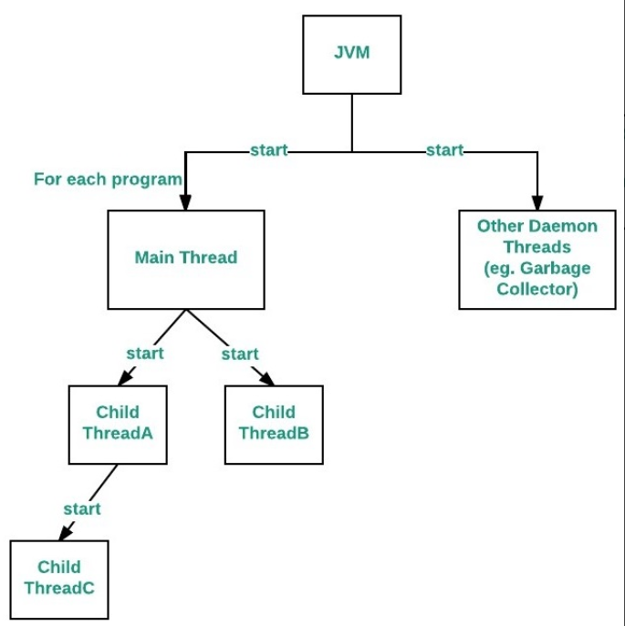
Thread.start() vs Thread.run() Method
Thread.start() | Thread.run()
Creates a new thread and the run() method is executed on the newly created thread. | No new thread is created and the run() method is executed on the calling thread itself.
It can't be invoked more than one time otherwise throws java.lang.IllegalStateException | Multiple invocations are possible.
Defined in java.lang.Thread class. | Defined in java.lang.Runnable interface and must be overridden in the implementing class.

New Thread Creation
When a program calls the start() method, a new thread is created and then the run() method is executed. But if we directly call the run() method then no new thread will be created and run() method will be executed as a normal method call on the current calling thread itself and no multi-threading will take place.
IllegalThreadStateException is thrown when thread is start twice using start() method
Q).Thread.sleep(-100):
java.lang.IllegalArgumentException: timeout value is negative
Java Daemon Thread
daemon threads are low-priority threads that run in the background to perform tasks such as garbage collection or provide services to user threads.
The life of a daemon thread depends on the mercy of user threads, meaning that when all user threads finish their execution, the Java Virtual Machine (JVM) automatically terminates the daemon thread.
To put it simply, daemon threads serve user threads by handling background tasks and have no role other than supporting the main execution.
Some examples of daemon threads in Java include garbage collection (gc) and finalizer. These threads work silently in the background, performing tasks that support the main execution without interfering with the user's operations.

Properties of Java Daemon Thread
Aspect | Description
No Preventing JVM Exit | Daemon threads cannot prevent the JVM from exiting when all user threads finish their execution. If all user threads complete their tasks, the JVM terminates itself, regardless of whether any daemon threads are running.
Automatic Termination | If the JVM detects a running daemon thread, it terminates the thread and subsequently shuts it down. The JVM does not check if the daemon thread is actively running; it terminates it regardless.
Low Priority | Daemon threads have the lowest priority among all threads in Java.
Default Nature of Daemon Thread | By default, the main thread is always a non-daemon thread. However, for all other threads, their daemon nature is inherited from their parent thread. If the parent thread is a daemon, the child thread is also a daemon, and if the parent thread is a non-daemon, the child thread is also a non-daemon.

🔑 Key Concepts of Daemon Threads in Java
1. setDaemon(boolean status)
- Marks a thread as daemon (true) or user (false).
- Must be called before start().
- Syntax: public final void setDaemon(boolean on)
- Exceptions:
  - IllegalThreadStateException: if called after thread starts.
  - SecurityException: if current thread lacks permission.
2. isDaemon()
- Checks if a thread is a daemon.
- Syntax: public final boolean isDaemon()
- Returns: true if daemon, false otherwise.
⚠️ Common Issues
Case 1: Output Not Printed
- Daemon thread may not run if JVM exits too quickly.
- Solution: Use Thread.sleep() in main() to delay JVM shutdown.
Case 2: Calling setDaemon() After start()
- Throws IllegalThreadStateException.
- Best Practice: Always set daemon status before starting the thread.

🆚 Daemon vs User Threads
Feature | Daemon Thread | User Thread
Purpose | Background support | Main application logic
JVM Behavior | JVM exits when only daemon threads run | JVM continues until all threads end
Usage | Logging, garbage collection, timers | Business logic, UI, computation

Java Thread Safety and How to Achieve it?
Thread Safety means when multiple threads access the same object or piece of code at the same time, the program still behaves correctly, without data corruption or unexpected results.
- A class or method is thread-safe if it works fine even when accessed by many threads at once.
- Even if threads run in any order, the shared data will always remain correct.
How to Achieve Thread Safety in Java?
There are four ways to achieve Thread Safety in Java. These are:
- Using Synchronization
- Using Volatile Keyword
- Using Atomic Variable
- Using Immutable Objects

1. Using Synchronization
-We use the synchronized keyword to ensure only one thread can access a method or block of code at a time.
- It helps in preventing race conditions.
Example:
class A {
synchronized void sum(int n) {
// Creating a thread instance
Thread t = Thread.currentThread();
for (int i = 1; i <= 5; i++) {
System.out.println(t.getName() + " : " + (n + i));
}
}
} // Class B extending thread class
class B extends Thread {
// Creating an object of class A
A a = new A();
public void run(){
// Calling sum() method
a.sum(10);
}
}
​
class Geeks {
public static void main(String[] args){
// Creating an object of class B
B b = new B();
// Initializing instance t1 of Thread class with object of class B
Thread t1 = new Thread(b);
// Initializing instance t2 of Thread class with object of class B
Thread t2 = new Thread(b);
// Initializing thread t1 with name 'Thread A'
t1.setName("Thread A");
// Initializing thread t2 with name 'Thread B'
t2.setName("Thread B");
// Starting thread instance t1 and t2
t1.start();
t2.start();
}
}

Output
Thread A : 11
Thread A : 12
Thread A : 13
Thread A : 14
Thread A : 15
Thread B : 11
Thread B : 12
Thread B : 13
Thread B : 14
Thread B : 15

2. Using Volatile Keyword
-Volatile Keyword ensures visibility of variable changes across threads. It does not guarantee atomicity,
- but ensures every thread reads the latest value from main memory, not cache.
Example:
public class Geeks {
// Initializing volatile variables a, b
static volatile int a = 0, b = 0;
// Defining a static void method
static void method_one() {
a++;
b++;
}
// Defining static void method
static void method_two() {
System.out.println("a=" + a +
" b=" + b);
}

public static void main(String[] args) {
// Creating an instance t1 of Thread class
Thread t1 = new Thread() {
public void run(){
for (int i = 0; i < 5; i++)
method_one();
}
};
// Creating an instance t2 of Thread class
Thread t2 = new Thread() {
public void run() {
for (int i = 0; i < 5; i++)
method_two();
}
};
// Starting instance t1 and t2
t1.start();
t2.start();
}
}

Output
a=5 b=5
a=5 b=5
a=5 b=5
a=5 b=5
a=5 b=5
3. Using Atomic Variable
-Using an atomic variable is another way to achieve thread-safety in java. When variables are shared by multiple threads,
-the atomic variable ensures that threads don't crash into each other.
import java.util.concurrent.atomic.AtomicInteger;
class Counter {
// Creating a variable of class type AtomicInteger
AtomicInteger count = new AtomicInteger();
// Defining increment() method to change value of AtomicInteger variable
public void increment() {
count.incrementAndGet();
}
}

public class TestCounter {
public static void main(String[] args) throws Exception {
// Creating an instance of Counter class
Counter c = new Counter();
// Creating an instance t1 of Thread class
Thread t1 = new Thread(new Runnable() {
public void run() {
for(int i = 1; i <= 2000; i++) {
c.increment();
}
}
});
// Creating an instance t2 of Thread class
Thread t2 = new Thread(new Runnable() {
public void run() {
for (int i = 1; i <= 2000; i++) {
c.increment();
}
}
});

// Calling start() method with t1 and t2
t1.start();
t2.start();
​
// Calling join method with t1 and t2
t1.join();
t2.join();
​
System.out.println(c.count);
}
}
Output
4000

4. Using Immutable Objects
Immutable objects are inherently thread-safe, as their state cannot change after creation. Mark fields as final and don’t provide setters.
final class Student {
private final String name;
private final int rollNo;
public Student(String name, int rollNo) {
this.name = name;
this.rollNo = rollNo;
}
public String getName() {
return name;
}
public int getRollNo() {
return rollNo;
}
}

Thread Safety vs Non-thread Safety
Features | Thread-Safe | Non-Thread Safe
Definition | It is used to handle concurrent access by multiple threads safely | Not designed for safe concurrent access by multiple threads
Synchronization | Uses synchronization internally for Thread safety | It does not use synchronization; access must be manually managed.
Use Case | It is used in multi-threaded environments. | It is mainly used for single-threaded scenarios or with external sync.
Performance | Slower due to synchronization overhead. | Faster, as there’s no locking mechanism.
Scalability | May not scale well under high concurrency due to lock contention | Scales well if used in a controlled single-threaded context
Examples | Vector, Hashtable, ConcurrentHashMap, StringBuffer | ArrayList, HashMap, StringBuilder, SimpleDateFormat

Thread Pool
-Thread Pool is collection of predefined, reusable thread that are kept ready to perform tasks
-instead of creating a new threads every time we need to run something(which is costly in terms of memory and cpu)
-thread pool maintain a fixed number of threads when a task is submitted
1.if the thread is free, it immediately picks up the task and runs it
2.if all thread are busy, the task waits in a queue until a thread become available
3.after finishing a task, the thread does not die.it goes back to the pool and waits for the next task
Thread Safety vs Non-thread Safety

Features | Thread-Safe | Non-Thread Safe
Definition | It is used to handle concurrent access by multiple threads safely | Not designed for safe concurrent access by multiple threads
Synchronization | Uses synchronization internally for Thread safety | It does not use synchronization; access must be manually managed.
Use Case | It is used in multi-threaded environments. | It is mainly used for single-threaded scenarios or with external sync.
Performance | Slower due to synchronization overhead. | Faster, as there’s no locking mechanism.
Scalability | May not scale well under high concurrency due to lock contention | Scales well if used in a controlled single-threaded context
Examples | Vector, Hashtable, ConcurrentHashMap, StringBuffer | ArrayList, HashMap, StringBuilder, SimpleDateFormat

Synchronization in java
-synchronization is imp to make sure multiple threads safely work on the same shared resources
-without synchronization ,data can become inconsistent or corrupted if multiple thread access and modify shared variable at same time
-it is mechanism, that ensures that only one thread can access a resources at any given time
-synchronization process helps prevent issue such as data inconsistency and race condition when multiple threads interact with shared resources
class Counter1{
private int c=0;
public synchronized void increment(){
c++;
}
public synchronized int getIncrement(){
return c;
}
}
public class synchronized1_count {
public static void main(String[] args) {
Counter1 cnt=new Counter1();
Thread t1=new Thread(()->{
for(int i=0;i<1000;i++){
cnt.increment();
}
});

Thread t2=new Thread(()->{
for(int i=0;i<1000;i++){
cnt.increment();
}
});
t1.start();
t2.start();
try{
//wait both thread to finish the work
t1.join();
t2.join();
} catch (InterruptedException e) {
e.printStackTrace();
}
System.out.println("counter:"+cnt.getIncrement());
}
}
Synchronized block in java
-synchronized blocks in java are marked with the synchronized keyword
-all synchronized blocks synchronize on the same object and can only have one thread execute inside then at a time
-all other thread attempting to enter the synchronized block are blocked until the thread inside the synchronized block exist the blok
General Form of Synchronized Block
synchronized(sync_object)
{
// Access shared variables and other shared resources
}
class Counter1{
private int c=0;
private int c1=0;
public synchronized void increment(){
c++;
}
public synchronized int getIncrement(){
return c;
}
// Method with synchronization block----------------------------------------------------
public void inc() {
synchronized(this) { // Synchronize only this block
c1++;
}
}
// Method to get counter value
public int get() {
return c1;
}
}
public class synchronized1_count {
public static void main(String[] args) {
Counter1 cnt=new Counter1();
System.out.println("thread-1 execute.......");
Thread t1=new Thread(()->{
for(int i=0;i<1000;i++){
cnt.increment();
}
});

System.out.println("thread-2 execute......");
Thread t2=new Thread(()->{
for(int i=0;i<1000;i++){
cnt.increment();
}
});
System.out.println("thread-3 execute......");
Thread t3=new Thread(()->{
for(int i=0;i<500;i++){
cnt.inc();
}
});
System.out.println("thread-4.........");
Thread t4=new Thread(()->{
for(int i=0;i<500;i++){
cnt.inc();
}
});
t1.start();
t2.start();
try{
//wait both thread to finish the work
System.out.println("thread-1 wait start----------------");
t1.join();
System.out.println("thread-1 wait end and Thread-2 wait start----------------");
t2.join();
System.out.println("thread-2 wait end----------------");
} catch (InterruptedException e) {
e.printStackTrace();
}

System.out.println("Total counter of synchronized method::"+cnt.getIncrement());
t3.start();
t4.start();
try{
System.out.println("thread-3 wait start----------------");
t3.join();
System.out.println("thread-3 wait end and Thread-4 wait start----------------");
t4.join();
System.out.println("thread-4 wait end-----------");
} catch (InterruptedException e) {
e.printStackTrace();
}
System.out.println("Total counter of synchronized block::"+cnt.get());
}
}
Types of Synchronization
-Process based Synchronization
-Thread based Synchronization
1. Process Synchronization in Java
-Process based synchronization is a technique used to coordinate the execution of multiple processes
-it ensures that shared resources are safe and in order

/*-Demonstrates process synchronization using a shared BankAccount object.
-Two threads operate concurrently: one for depositing, one for withdrawing.
-Both deposit() and withdraw() methods are marked as synchronized.
-synchronized ensures mutual exclusion only one thread can access the balance at a time.
-Prevents race conditions when threads access or modify the balance simultaneously.
-Ensures thread safety and maintains a consistent, accurate account balance.*/
class Bankaccount{
private int balance=1000; //sharing resources bank balance
//synchronized method for deposit operation-----------------------------
public synchronized void deposite(int amount){
balance+=amount;
System.out.println("Deposited: "+amount+",balance: "+balance);
}
//synchronized method for withdrawal operation------------------------
public synchronized void withdraw(int amount){
if(balance>=amount){
balance-=amount; System.out.println("withdrawn:"+amount+",Balance:"+balance);
}else{
System.out.println("Insufficient balance to withdraw:"+amount);
}
}
//get balance method-------------------------------------------------------------
public int getBalance(){
return balance;
}
}
public class bank_synchronized {
public static void main(String[] args) {
Bankaccount acc=new Bankaccount(); //shared resources
//thread-1 to deposit money into account-----------------------
Thread t1=new Thread(()->{
for(int i=0;i<3;i++){
acc.deposite(200);
try{
Thread.sleep(1000);
} catch (InterruptedException e) {
System.out.println("amount deposit processing wait.....!");
e.printStackTrace();
}
}
});

//thread-1 to deposit money into account---------------------
Thread t2=new Thread(()->{
for(int i=0;i<3;i++){
acc.withdraw(100);
try{
Thread.sleep(1000);
} catch (InterruptedException e) {
System.out.println("amount withdraw processing wait.....!");
e.printStackTrace();
}
}
});
//start both threads
t1.start();
t2.start();
//wait for both thread to finish its works------------------
try{
t1.join();
t2.join();
}catch (InterruptedException e){
e.printStackTrace();
}
//print the final balance----------------------------------
System.out.println("final balance:"+acc.getBalance());
}
}

2)Thread Synchronization in java
-Thread Synchronization is used to coordinate and ordering of of the execution of the thread in multithread program
-there are two type of the thread in multithread program
1.mutual exclusion
2.cooperation(inter thread communication in java)
/*
-Uses a shared TicketBooking class with a synchronized bookTicket() method.
-Ensures only one thread can book tickets at a time, preventing race conditions.
-Multiple threads try booking tickets in a loop.
-availableTickets is safely accessed and updated through synchronization.
-Prevents overbooking and ensures thread-safe ticket allocation.
-The program prints the remaining available tickets after all booking attempts.
*/
class TicketBooking{
private int totalTicket=10; //total available ticket
//synchronized method for booking tickets
public synchronized void bookTicket(int tickets){
if(totalTicket>=tickets){
totalTicket-=tickets;
System.out.println("Booked "+tickets+" tickets,Remaining tickets:"+totalTicket);
}else{
System.out.println("not enough tickets available to book:"+tickets);
}
}

public int getTicketCount(){
return totalTicket;
}
}
public class Ticket_thread_synchronized {
public static void main(String[] args) {
TicketBooking tic=new TicketBooking(); //shared resources
//thread-1 to book tickets----------------------------------------------------------
Thread t1=new Thread(()->{
for (int i=0;i<2;i++){
tic.bookTicket(2); //trying to book 2 tickets
try{
Thread.sleep(1000);
} catch (InterruptedException e) {
e.printStackTrace();
}
}
});
//thread-2 to book tickets----------------------------------------------------------
Thread t2=new Thread(()->{
for (int i=0;i<2;i++){
tic.bookTicket(3); //trying to book 2 tickets
try{
Thread.sleep(500);
} catch (InterruptedException e) {
e.printStackTrace();
}
}
});

//start both threads---------------------------------------
t1.start();
t2.start();
try{
t1.join();
t2.join();
} catch (InterruptedException e) {
e.printStackTrace();
}
//print final remaining tickets---------------
System.out.println("Final available Tickets:"+tic.getTicketCount());
}
}
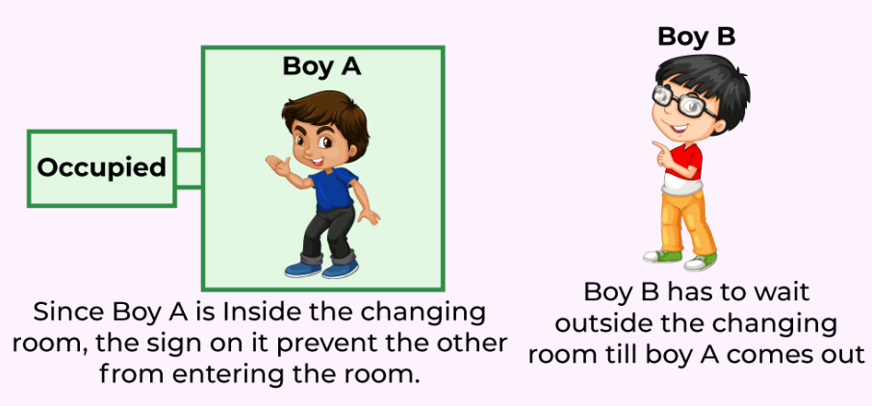
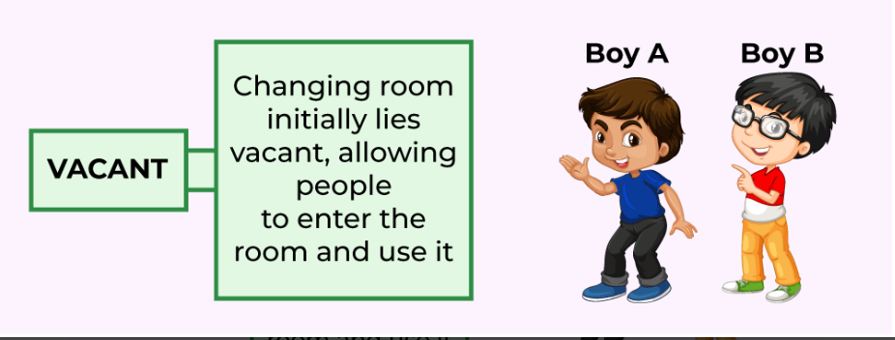

🔐 What is Mutual Exclusion?
- Ensures that only one process can access the critical section at a time.
- Prevents race conditions, where outcomes depend on the sequence of process execution.
- Coined by Edsger Dijkstra.
- Essential for process synchronization in concurrent systems.
⚙️ Why Is It Needed?
- To maintain data consistency in shared resources.
- Avoids simultaneous updates that can corrupt shared data structures (e.g., linked lists).
- Prevents conflicts during concurrent access to resources like files, printers, or variables.
🧠 Types of Concurrent Execution
- Interrupt handlers
- Interleaved or preemptively scheduled threads
- Multiprocessor systems with shared memory
- Distributed systems
📋 Conditions for Mutual Exclusion
- No two processes can be in their critical sections simultaneously.
- No assumptions about process execution speed.
- A process outside the critical section must not block others.
- Entry to the critical section must occur in finite time (no indefinite waiting).
🛠️ Approaches to Implement Mutual Exclusion
- Software Methods: Logic built into processes; error-prone and slow.
- Hardware Methods: Use special machine instructions; fast but not foolproof.
- Programming Language Support: OS or language-level constructs (e.g., mutexes, semaphores).
✅ Requirements of a Good Mutual Exclusion Solution
- Only one process in the critical section at a time.
- Implemented purely in software.
- Bounded time inside the critical section.
- No assumptions about process speed.
- No process can indefinitely block another.
- No process should be starved of access.
🧵 Example: Linked List Race Condition
- Two threads removing nodes simultaneously can leave the list in an inconsistent state.
- Mutual exclusion ensures updates happen one at a time, preserving list integrity.
🛍️ Real-Life Analogy: Changing Room
- One person uses the room while the sign shows "occupied".
- Others wait until it becomes "vacant".
- The changing room = critical section; the sign = synchronization mechanism.
🧾 Conclusion
- Mutual exclusion is vital for safe and reliable concurrent programming.
- It ensures data integrity, prevents conflicts, and supports efficient multitasking.
🔄 What Is Inter-thread Communication?
- A mechanism where one thread pauses in its critical section to allow another thread to enter and execute.
- Also known as Cooperation in Java.
- Enables efficient synchronization between threads.
🧪 Polling and Its Problems
- Polling: Repeatedly checking a condition until it becomes true.
- Problems:
  - Wastes CPU cycles.
  - Slows down execution.
  - Inefficient for thread coordination.
🛠️ Java’s Solution: wait(), notify(), notifyAll()
- All three methods are part of the Object class.
- Must be used inside a synchronized block.
- wait(): Releases the lock and puts the thread to sleep until notified.
- notify(): Wakes up one waiting thread.
- notifyAll(): Wakes up all waiting threads.
🧵 Producer-Consumer Problem
- Producer: Adds items to a shared queue.
- Consumer: Removes items from the queue.
- Uses wait() and notifyAll() to avoid polling and ensure smooth coordination.

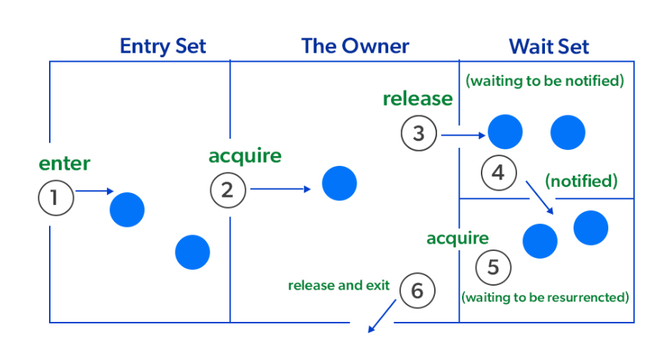
🧑‍💻 Java Program Highlights
- Shared Queue: LinkedList with a capacity of 10.
- Producer Thread:
  - Waits if queue is full.
  - Adds item and notifies consumers.
  - Sleeps for 2 seconds to simulate delay.
- Consumer Thread:
  - Waits if queue is empty.
  - Removes item and notifies producers.
  - Sleeps for 2 seconds to simulate delay.
- Main Method:
  - Starts both threads.
  - Prints start and exit messages.
🖥️ Output Behavior
- Producer adds items when space is available.
- Consumer removes items when available.
- Threads wait and notify each other to avoid busy-waiting.
- Demonstrates efficient inter-thread communication.
✅ Key Takeaways
- Inter-thread communication avoids inefficient polling.
- wait(), notify(), and notifyAll() are essential for thread cooperation.
- Synchronization ensures safe access to shared resources.
- Helps build responsive and resource-efficient multithreaded applications.
import java.util.LinkedList;
import java.util.Queue;
public class Geeks {
// Shared queue used by both producer and consumer
private static final Queue<Integer> queue = new LinkedList<>();
// Maximum capacity of the queue
private static final int CAPACITY = 10;
// Producer task
private static final Runnable producer = new Runnable() {
public void run() {
while (true) {
synchronized (queue) {
// Wait if the queue is full
while (queue.size() == CAPACITY) {
try {
System.out.println("Queue is at max capacity");
queue.wait(); // Release the lock and wait
} catch (InterruptedException e) {
e.printStackTrace(); }}
// Add item to the queue
queue.add(10);
System.out.println("Added 10 to the queue");
queue.notifyAll(); // Notify all waiting consumers
try {
Thread.sleep(2000);
} catch (InterruptedException e) {
e.printStackTrace();
} }}}};
// Consumer task-----------------------------------------------------------------------
private static final Runnable consumer = new Runnable() {
public void run() {
while (true) {
synchronized (queue) {
// Wait if the queue is empty
while (queue.isEmpty()) {
try {
System.out.println("Queue is empty, waiting");
queue.wait(); // Release the lock and wait
} catch (InterruptedException e) {
e.printStackTrace();
}
}

// Remove item from the queue
System.out.println("Removed " + queue.remove() + " from the queue");
queue.notifyAll(); // Notify all waiting producers
try {
Thread.sleep(2000);
} catch (InterruptedException e) {
e.printStackTrace();
}}} }};
public static void main(String[] args) {
System.out.println("Main thread started");
// Create and start the producer thread
Thread producerThread = new Thread(producer, "Producer");
// Create and start the consumer thread
Thread consumerThread = new Thread(consumer, "Consumer");
producerThread.start();
consumerThread.start();
System.out.println("Main thread exiting");
}
}

2.Producer and consumer Problem
import java.util.LinkedList;
import java.util.Queue;
public class Geeks {
// Shared queue used by both producer and consumer
private static final Queue<Integer> queue = new LinkedList<>();
private static final int CAPACITY = 10;
// Producer task
private static final Runnable producer = new Runnable() {
public void run() {
while (true) {
synchronized (queue) {
while (queue.size() == CAPACITY) {
try {
System.out.println("Queue is at max capacity");
queue.wait(); // Release the lock and wait
} catch (InterruptedException e) {
e.printStackTrace();
}
}
queue.add(10);
System.out.println("Added 10 to the queue");
queue.notifyAll(); // Notify all waiting consumers

try {
Thread.sleep(2000); // Simulate production delay
} catch (InterruptedException e) {
e.printStackTrace();
}
}
}
}
};
// Consumer task-------------------------------------------------------------------------------
private static final Runnable consumer = new Runnable() {
public void run() {
while (true) {
synchronized (queue) {
while (queue.isEmpty()) {
try {
System.out.println("Queue is empty, waiting");
queue.wait(); // Release the lock and wait
} catch (InterruptedException e) {
e.printStackTrace();
}
}
System.out.println("Removed " + queue.remove() + " from the queue");
queue.notifyAll(); // Notify all waiting producers
try {
Thread.sleep(2000); // Simulate consumption delay
} catch (InterruptedException e) {
e.printStackTrace();
}
}
}
}
};
public static void main(String[] args) {
System.out.println("Main thread started");
Thread producerThread = new Thread(producer, "Producer");
Thread consumerThread = new Thread(consumer, "Consumer");

producerThread.start();
consumerThread.start();

System.out.println("Main thread exiting");
}
}

🔐 Mutual Exclusion in Java
✅ Purpose
- Prevents multiple threads from accessing shared resources simultaneously.
- Ensures thread safety and avoids race conditions.
🧩 Types of Mutual Exclusion
- Synchronized Method
- Synchronized Block
- Static Synchronization
📦 Example 1: Synchronized Block
class Sender {
public void send(String msg) {
System.out.println("Sending " + msg);
try { Thread.sleep(100); } catch (Exception e) {}
System.out.println(msg + "Sent");
}
}
class ThreadedSend extends Thread {
private String msg;
Sender sender;
ThreadedSend(String m, Sender obj) {
msg = m;
sender = obj;
}
public void run() {
synchronized (sender) {
sender.send(msg);
}
}
}
public class Geeks {
public static void main(String[] args) {
Sender send = new Sender();
ThreadedSend S1 = new ThreadedSend("Hi ", send);
ThreadedSend S2 = new ThreadedSend("Bye ", send);
S1.start();
S2.start();
try {
S1.join();
S2.join();
} catch (Exception e) {}
}
}
🧠 Explanation
- synchronized(sender) ensures only one thread sends a message at a time.
- Prevents concurrent access to the send() method.

📦 Example 2: Synchronized Method
class Test {
synchronized void test_func(int n) {
for (int i = 1; i <= 3; i++) {
System.out.println(n + i);
try { Thread.sleep(100); } catch (Exception e) {}
}
}
}
public class Geeks {
public static void main(String[] args) {
final Test O = new Test();
Thread a = new Thread() {
public void run() { O.test_func(15); }
};
Thread b = new Thread() {
public void run() { O.test_func(30); }
};
a.start();
b.start();
}
}

3. Static Synchronization
In this, the synchronized method is declared as "static" which means the lock or monitor is applied on the class not on the object so that only one thread will access the class at a time.
Example:
// Java Program Illustrate Synchronized Using static synchronization Helper class
class PrintTest extends Thread {
// Static synchronization locks the class PrintTest
synchronized public static void printThread(int n){
for (int i = 1; i <= 10; i++) {
System.out.println("Thread " + n + " is working...");
// Try block to check for exceptions
try {
// making thread to sleep for 0.6 seconds
Thread.sleep(600);
} // Catch block to handle the exceptions
catch (Exception ex) {
System.out.println(ex.toString());
}
}

System.out.println("--------------------------");
try {
Thread.sleep(1000);
}
catch (Exception ex) {
System.out.println(ex.toString());
}
}
}
// Helper class extending Thread class
class Thread1 extends Thread {
// run() method for thread
public void run() {
// Passing the class not the object
PrintTest.printThread(1);
}
}
// Helper class extending Thread class
class Thread2 extends Thread {
public void run() {
// Passing the class not the object
PrintTest.printThread(2);
}
}

// Main class
class SynchroTest {
public static void main(String[] args)
{
// No shared object
// Creating objects of class 2 and 3 that
// are extending to Thread class
Thread1 t1 = new Thread1();
Thread2 t2 = new Thread2();

// Starting thread with help of start() method
t1.start();
t2.start();
}
}

🧵 Quick Summary: Synchronized vs Volatile vs Atomic
Feature | synchronized | volatile | Atomic (e.g., AtomicInteger)
Applies to | Methods / Code blocks | Variables | Variables
Guarantees | Mutual exclusion + visibility | Visibility only | Atomicity + visibility
Locking | Yes (intrinsic lock) | No | No (uses CAS)
Performance | Lower (due to lock contention) | Higher than synchronized | Highest (lock-free)
Thread Safety | Yes | Partially (not for compound ops) | Yes
Risk | Deadlocks, livelocks | Race conditions on compound ops | None (for supported atomic ops)

🛠️ When to Use What
✅ Use synchronized when:
- You need mutual exclusion for compound operations (e.g., read-modify-write).
- You’re working with critical sections involving multiple shared variables.
- You want to coordinate access to shared resources like collections or files.
✅ Use volatile when:
- You only need visibility, not atomicity.
- The variable is read and written independently, like a flag (isRunning, shutdownRequested).
- You want a lightweight alternative to synchronization for simple state sharing.
✅ Use Atomic classes when:
- You need atomic operations on single variables (e.g., counters, flags).
- You want high performance without locks.
- You’re working with concurrent algorithms that rely on CAS (Compare-And-Swap).
💡 Pro Tip
If you're incrementing a shared counter:
- volatile int count; count++; → ❌ Not thread-safe
- AtomicInteger count; count.incrementAndGet(); → ✅ Thread-safe
- synchronized void increment() { count++; } → ✅ Thread-safe but slower

Deadlock in Java Multithreading
Deadlock occurs in Java when multiple threads block each other while waiting for locks held by one another. To prevent deadlocks,
we can use the synchronized keyword to make methods or blocks thread-safe which means only one thread can have the lock of the synchronized method and use it, other threads have to wait till the lock releases other one acquires the lock.
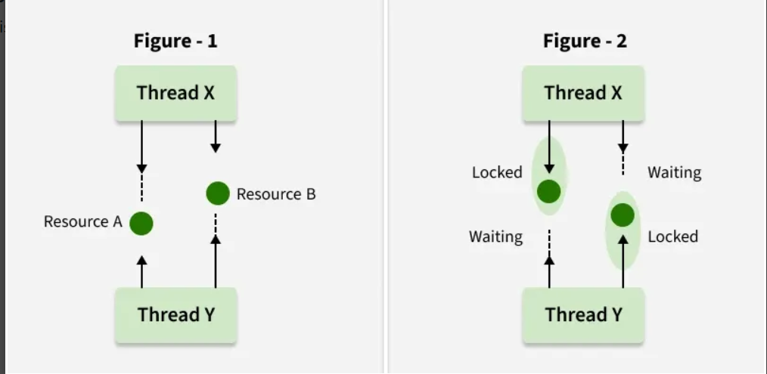

Preventing Deadlocks
Deadlocks occur when threads hold resources and wait for others in a circular way, causing each thread to wait indefinitely.
Instance method synchronization locks the object itself.
We can avoid deadlock conditions by knowing its possibilities. It's a very complex process and not easy to catch. Still, if we try, we can avoid this. There are some methods by which we can avoid this condition. We can't completely remove its possibility but we can reduce it.
- Avoid Nested Locks: This is the main reason for deadlock. Mainly happens when we give locks to multiple threads. Avoid giving lock to multiple threads if we already have given to one.
- Avoid Unnecessary Locks: We should have lock only those members who are required. Having a lock on unnecessarily can lead to deadlock.
- Using thread join: Deadlock condition appears when one thread is waiting for the other to finish. If this condition occurs we can use Thread. Join the with the maximum time you think the execution will take.
- Deadlock occurs when two threads hold locks and wait for each other
- B
Deadlock can be avoided by acquiring locks in the same order
- Deadlock can be prevented by using tryLock() in ReentrantLock
class A {
synchronized void method1(B b) {
b.last();
}
synchronized void last() {}
}

class B {
synchronized void method1(A a) {
a.last();
}
synchronized void last() {}
}
This code can result in a deadlock because each thread holds one lock and waits for the other.
The synchronized keyword ensures that only one thread at a time can execute the synchronized method or block
Deadlock can be avoided by ensuring that threads always acquire locks in a predefined order.ie
By acquiring locks in a consistent order
ReentrantLock allows interruptible and flexible lock handling, as well as features like timed lock acquisition and multiple lock attempts.

class Geeks {
private int counter = 0;
public synchronized void increment() {
counter++;
}
public synchronized int getCounter() {
return counter;
}
}
The synchronized keyword is used on the methods to ensure thread safety by allowing only one thread to execute them at a time.
Lock lock = new ReentrantLock();
lock.lock();
try {
// critical section
lock.lock(); // Reentrant lock acquired again
} finally {
lock.unlock();
lock.unlock(); // Release both locks
}
ReentrantLock allows a thread to lock the same resource multiple times, which is why it works without deadlock in this case.

Deadlock Prevention
Deadlock prevention is a strategy used in computer systems to ensure that different processes can run smoothly without getting stuck waiting for each other forever. Think of it like a traffic system where cars (processes) must move through intersections (resources) without getting into a gridlock.
As we have already discussed that deadlock can only happen if all four of the following conditions are met simultaneously:
- Mutual Exclusion
- Hold and Wait
- No Preemption
- Circular Wait
1. Eliminate Mutual Exclusion
- Some resources, like a printer, are inherently non-sharable, so this condition is difficult to break.
- However, sharable resources like read-only files can be accessed by multiple processes at the same time.
- For non-sharable resources, prevention through this method is not possible.
2. Eliminate Hold and Wait
Hold and wait is a condition in which a process holds one resource while simultaneously waiting for another resource that is being held by a different process. The process cannot continue until it gets all the required resources.
Hold & Wait
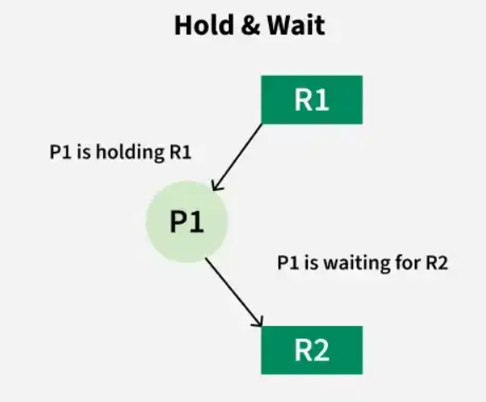
There are two ways to eliminate hold and wait:
- By eliminating wait: The process specifies the resources it requires in advance so that it does not have to wait for allocation after execution starts.
For Example, Process1 declares in advance that it requires both Resource1 and Resource2.
- By eliminating hold: The process has to release all resources it is currently holding before making a new request.
For Example: Process1 must release Resource2 and Resource3 before requesting Resource1.
3. Eliminate No Preemption
No pre-emption. means resources can’t be taken away once allocated. To prevent this:
- Processes must release resources voluntarily: A process gives up resources once it finishes using them.
- Avoid partial allocation: If a process requests resources that are unavailable, it must release all currently held resources and wait until all required resources are free.

4. Eliminate Circular Wait
Circular wait happens when processes form a cycle, each waiting for a resource held by the next. To prevent this:
- Impose a strict ordering on resources.
- Assign each resource a unique number.
- Processes can only request resources in increasing order of their numbers.
- This prevents cycles, as no process can go backwards in numbering.

Difference Between Lock and Monitor in Java Concurrency

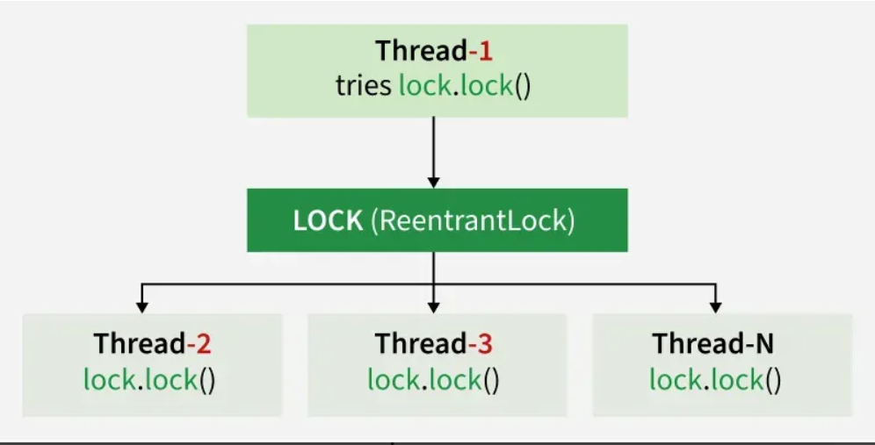
1.Lock in Java
Lock is a tool for controlling access to shared resources by multiple threads. It’s part of the java.util.concurrent.locks package, introduced in Java 5 and is an alternative to the traditional synchronized keyword.

Aspect | Lock | Monitor
Origin | Early synchronization tool. | Came with advanced thread synchronization (synchronized).
Implementation | Explicit via lock() / unlock(). | Implicit via synchronized.
Critical Section | Managed manually by programmer. | Managed automatically by JVM.
Synchronization | Explicitly handled by threads. | Automatically handled by shared object.
Coupling | Loosely coupled (threads manage access). | Tightly coupled (object manages synchronization).
Performance | Error-prone, may cause deadlocks if misused. | Simpler, better for small thread pools, less control.
Thread Mgmt | OS/program explicitly manages threads. | Monitor queues and manages threads internally.
Usage | Less common, used via java.util.concurrent.locks. | Widely used, easier to implement with synchronized.
Note: As monitors themselves are implemented with the necessary support of locks, it is often said that they are not different but complementary in their existence.
1.Monitor lock
In Java, a Monitor is a synchronization construct that controls access to shared resources among multiple threads. Every Java object can act as a monitor.
A monitor allows only one thread at a time to execute a synchronized method or block on that object. Other threads requesting the same object’s synchronized block are blocked until the lock is released. Monitors use intrinsic locks (object-level locks).
1).What is the key difference between a Lock and a Monitor in Java concurrency?
Ans: Lock provides more flexibility for controlling concurrency than Monitor, which is associated with the synchronized keyword
-Lock provides more control and flexibility, including options like tryLock() and lockInterruptibly(), whereas Monitor is used with the synchronized keyword for basic thread synchronization.
2).Which of the following can help in deadlock prevention when acquiring multiple locks in a multithreaded program?
Ans: Acquiring locks in a consistent order
-Deadlock can be prevented by ensuring that threads acquire locks in a consistent order, which avoids circular dependencies that lead to deadlock.
3)What does the ReentrantLock class provide that a synchronized block does not?
Ans: The ability to acquire a lock multiple times by the same thread
-ReentrantLock allows a thread to acquire the same lock multiple times, providing more flexibility for nested locks compared to synchronized blocks.
4) Consider the following code snippet. Which of the following will result in a deadlock?
Java class A {
Lock lock1 = new ReentrantLock();
Lock lock2 = new ReentrantLock();
void method1() {
lock1.lock();
lock2.lock();
try {
// Critical section
} finally {
lock1.unlock();
lock2.unlock();
}
}
}

class B {
Lock lock1 = new ReentrantLock();
Lock lock2 = new ReentrantLock();
void method1() {
lock2.lock();
lock1.lock();
try {
// Critical section
} finally {
lock1.unlock();
lock2.unlock();
}
}
}
-Deadlock will occur if A.method1() and B.method1() are executed simultaneously
-Deadlock can occur if A.method1() locks lock1 and lock2, while B.method1() locks them in the opposite order. This creates a circular wait, causing the threads to block each other indefinitely.
5) Which of the following is a method provided by ReentrantLock to acquire a lock but allows the thread to be interrupted?
Ans: lockInterruptibly()
lockInterruptibly() allows a thread to acquire the lock, but it can be interrupted if necessary, unlike lock(), which blocks the thread until the lock is acquired

6).What happens if two threads try to acquire the same lock using ReentrantLock simultaneously?
Ans: One thread will acquire the lock, and the other will block until the lock is released
-Only one thread can acquire the lock at a time. The other thread will be blocked until the lock is released by the first thread.
7) How can a thread avoid deadlock when acquiring multiple locks?
Ans: By acquiring all locks in the same order consistently
-Deadlock can be avoided by ensuring that threads acquire locks in a consistent order, thus preventing circular waits.
8) Which of the following methods in ReentrantLock allows a thread to acquire the lock only if it is available, without waiting indefinitely?
Ans: tryLock()
-tryLock() allows a thread to attempt to acquire the lock without blocking. It returns false if the lock is not available.
9) Which of the following accurately describes a fairness policy in ReentrantLock?
Ans: It grants access to the longest-waiting thread
-A fairness policy makes sure the thread that has been waiting the longest gets the lock first. This helps avoid starvation.
10) What is the primary purpose of using ReentrantLock over the synchronized block in Java?
Ans: To provide more advanced features, such as timed lock acquisition and lock interruptibility
-ReentrantLock provides additional features like tryLock(), lockInterruptibly(), and timed lock acquisition, which offer more flexibility than the synchronized block.

ReentrantLock in Java
ReentrantLock in Java is a part of the java.util.concurrent package that helps to achieve synchronization more effectively and optimally compared to the traditional Synchronized keyword. It offers features like,
- Timeouts
- Interruptible locks
- More control over Thread Scheduling
These features make it a valuable tool for managing concurrent access to shared resources with greater precision and adaptability.
A ReentrantLock allows a thread to acquire the same lock multiple times, which is particularly useful when a thread needs to access a shared resource repeatedly within its execution. It implements the Lock interface, providing greater control over locking compared to synchronized blocks.
- ReentrantLock tracks a "hold count", which:
- Starts at 1 when a thread first locks the resource.
- Each time the thread re-enters the lock, the count is incremented.
- The count is decremented when the lock is released.
- Once the hold count reaches zero, the lock is fully released.
Example 1: Below is a simple Java code demonstrating how to use ReentrantLock to prevent race conditions when accessing a shared counter.
// Java program to demonstrate the use of ReentrantLock
import java.util.concurrent.locks.ReentrantLock;
​class Geeks{
// counter value shared across the threads
private static int c = 0;
// Lock object
private static ReentrantLock lock = new ReentrantLock();
public static void increment(){
// acquire the lock
lock.lock();
try {
c++;
System.out.println(Thread.currentThread().getName()
+ " incremented counter to: " + c);
} finally{
// unlock used to
// release the lock
lock.unlock();
}
}
public static void main(String[] args) {
Runnable task = () -> {
for (int i = 1; i < 3 ; i++) {
increment();
}
};
Thread t1 = new Thread(task, "Thread-1");
Thread t2 = new Thread(task, "Thread-2");
t1.start();
t2.start(); } }
Output
Thread-1 incremented counter to: 1
Thread-2 incremented counter to: 2
Thread-2 incremented counter to: 3
Thread-1 incremented counter to: 4
Explanation: In the above example, the shared counter "c" multiple threads increment the counter, but the lock ensures only one thread accesses it at a time, preventing race conditions. The lock is acquired with lock.lock() and released with lock.unlock(). Unlock statement is always called in the finally block to ensure that the lock is released even if an exception is thrown in the method body(try block).
ReentrantLock() Methods
Methods | Description
lock() | Increments the hold count by 1 and gives the lock to the thread if the shared resource is initially free.
unlock() | Decrements the hold count by 1. When this count reaches zero, the resource is released.
tryLock() | If no other thread holds the resource, It returns true and increments the hold count. If busy, it returns false without blocking the thread
tryLock(long timeout, TimeUnit unit) | The thread waits for a certain period as defined by arguments of the method to acquire the lock on the resource before exiting.
lockInterruptibly() | Make Thread wait for a resource lock for a set time, interrupting if it times out or if the thread is interrupted.
getHoldCount() | Returns the count of the number of locks held on the resource.
isHeldByCurrentThread() | Returns true if the lock on the resource is held by the current thread.
hasQueuedThread() | Checks if there are any threads waiting to acquire the lock.
Islocked() | Queries if this lock is held by any thread.
newCondition() | Returns a Condition instance for use with this Lock instance.

Example 2: This example demonstrates how to use locks in Java. Below are the steps:
- Create an object of ReentrantLock.
- Create a worker (Runnable object) and pass the lock to it.
- Use the lock() method to acquire the lock on a shared resource.
- After completing work, call the unlock() method to release the lock.

// Java Program to demonstrate Reentrant Locks
import java.util.concurrent.ExecutorService;
import java.util.concurrent.Executors;
import java.util.concurrent.locks.ReentrantLock;
​class Worker implements Runnable {
private ReentrantLock lock;
private String name;
public Worker(ReentrantLock lock, String name) {
this.lock = lock;
this.name = name;
}
@Override
public void run() {
while (!lock.tryLock()) {
System.out.println(name + " waiting for lock");
}
System.out.println(name + " acquired lock");
// Release the lock after completing the task
lock.unlock();
System.out.println(name + " released lock");
}
}
​

public class Geeks {
public static void main(String[] args) {
ReentrantLock lock = new ReentrantLock();
ExecutorService pool = Executors.newFixedThreadPool(2);
// Lock acquiring
pool.execute(new Worker(lock, "Job1"));
pool.execute(new Worker(lock, "Job2"));
// Shutdown the executor service
pool.shutdown();
}
}
Output
Job1 acquired lock
Job1 released lock
Job2 waiting for lock
Job2 acquired lock
Job2 released lock
Explanation: Here, the Worker class attempts to acquire the lock with tryLock(). If the lock is unavailable, it waits and prints a message. Once acquired, it performs its task and releases the lock. The main method sets up a thread pool with two worker instances, allowing them to run concurrently while ensuring thread-safe access to resources.
Note: One can forget to call the unlock() method in the final leading to bugs in the program. Ensure that the lock is released before the thread exits.
Example 3: This example demonstrates how to use ReentrantLock with Condition objects to synchronize even and odd thread operations.
// Java program of ReentrantLock() With Conditions
import java.util.concurrent.locks.Condition;
import java.util.concurrent.locks.ReentrantLock;
class Geeks extends Thread{
ReentrantLock l = new ReentrantLock();
// Conditions for even/odd-----------------------------------------------
Condition ev = l.newCondition();
Condition od = l.newCondition();
// Counter variable---------------------------------------------------------------------------
int c;
Geeks(int c) { this.c = c; }
int MAX = 10;
public void run() {
while (c <= MAX) {
// Acquire the lock
l.lock();
try {
// Conditions
if (c % 2 == 1&& Thread.currentThread().getName().equals("even")) {
ev.await();
}

else if (c % 2 == 0&& Thread.currentThread().getName().equals("odd")) {
// Wait for odd condition
od.await();
}else {
System.out.println(Thread.currentThread().getName()+ " Thread " + c);
c += 1;
if (c % 2 == 0)
ev.signal();
else
od.signal();
}
} catch (InterruptedException e) {
e.printStackTrace();
}
finally{
// Release the lock
l.unlock();
}} }
public static void main(String[] args){
Geeks obj = new Geeks(0);
Thread even = new Thread(obj, "even");
Thread odd = new Thread(obj, "odd");
even.start();
odd.start(); }}
Output:: even Thread 0
odd Thread 1
even Thread 2
odd Thread 3
even Thread 4
odd Thread 5
even Thread 6
odd Thread 7
even Thread 8
odd Thread 9
even Thread 10
Explanation:
- In the above example, the even threads utilize an even Condition object to wait using the await() method and odd threads use an odd condition to wait using the await() method.
- When the shared resource is even, we release the even thread using the signal() method because the last printed value is an odd value generated by the odd thread.
- When the shared resource(t) is odd, release the odd thread using the signal() method because the last printed value is an even value produced by the even thread.
- Important Points:
- A thread waiting on a condition (e.g., evenCondition.await()) should not signal using the same condition (evenCondition.signal()).
- The await() and signal() methods in Condition behave similarly to wait() and notify() in synchronized blocks but provide finer-grained control.

-

